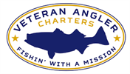
Veteran Angler Charters Tri-State Canyon Shootout Event

Veteran Angler Charters, in partnership with Eversource Energy and Orsted North America, is excited to offer an incredible opportunity this summer. The Tri-State Canyon Shootout is a 4-day offshore fishing tournament hosted at the Block Island Boat Basin on Block Island, R.I. This tournament is one of the summer’s premier events in the Northeast, drawing some of the biggest names and one of the largest sport fishing fleets in the northeast. This is an incredible opportunity to experience some highly competitive, contagious fishing fun. Veteran Angler Charters, with support from Eversource Energy and Orsted North America, will be sponsoring a veteran fishing team to compete in the Tri-State Canyon Shootout July 23-28, 2023. We are accepting nominations for this trip of a lifetime until 1 April 2023. Eligibility requirements to be considered for this trip are listed below. Three individuals will be selected to join the Veteran Angler Charters team during April 2023.

Event Dates:
Participants will need to be present on the morning of Sunday, July 23, 2023. The Veteran Angler Charters fishing team will depart Mystic, CT on July 23, 2023 and return on July 28, 2023. The fishing days of the tournament are Monday, July 24, 2023 through Thursday, July 27, 2023. Participating veterans are responsible for arranging transportation to and from Mystic, CT.

Lodging:
Lodging will be provided on Block Island by Veteran Angler Charters. Participants will be required to share a room with another participant of the same gender.

Food/Drink:
Veteran Angler Charters will provide a stipend to each participating veteran towards purchasing food and drink during the tournament. All food and drink will be provided by Veteran Angler Charters while on the boat.

Boat and Crew:
The Veteran Angler Charters team will be fishing with Capt. Jesse Martello of Think Big Charters, aboard the NECESSARY EXPENSE.

Costs:
The following costs will be covered by Veteran Angler Charters for the selected participants: tournament entry fee, all costs associated with the boat (fuel, tackle, bait, etc.), lodging, food/drink while on the boat, and a stipend towards food/drink while not on the boat. All winnings (monetary or otherwise) resulting from the tournament will be retained by Veteran Angler Charters, to be used to fund future fishing opportunities for disabled veterans.

The selected veterans are responsible for providing their own:
- Transportation to/from the port of departure (Mystic, CT)
- Clothing and other personal items needed for the duration of the event

Eligibility:
All applicants for consideration must meet the following eligibility requirements, which will be verified by Veteran Angler Charters after selection:
- Honorable discharge from the U.S. armed forces
- Service-connected disability (no minimum VA rating)
- Veteran must be available for the entire tournament (July 24-28, 2023)
- Meet the physical requirements provided below
- Must have a desire to actively participate in the tournament by fishing on all four fishing days

Physical Requirements:
As this is an offshore canyon fishing tournament and safety is our top priority, participating veterans must meet the following:
- Be able to stand and walk unsupported for extended periods of time
- Be capable of lifting up to 50 lbs.
- Not suffer from known sea or motion sickness
- Comfortable being on a small vessel offshore for two consecutive days, including overnight

How to Apply or Nominate a Veteran:
If you would like to be considered for selection, or if you would like to nominate someone for consideration, please completed the attached application and submit to tristate@veterananglercharters.org by 2359 EST on 1 April 2023. Incomplete applications and those received after the deadline will not be considered.

Selection:
Completed applications will be reviewed and three individuals will be selected on 1 April 2023. Selected individuals will be contacted to confirm their desire to participate and to verify eligibility. Veteran Angler Charters will also select three alternates, to be invited in order of selection in the event primary participants decline the invitation.

Eligible veterans who are not selected for this event are reminded that Veteran Angler Charters provides no-cost fishing trips to disabled veterans throughout the fishing season. For more information or to request to be considered for a day trip during the 2023 season, please visit www.veterananglercharters.org.

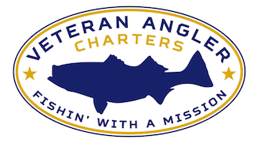
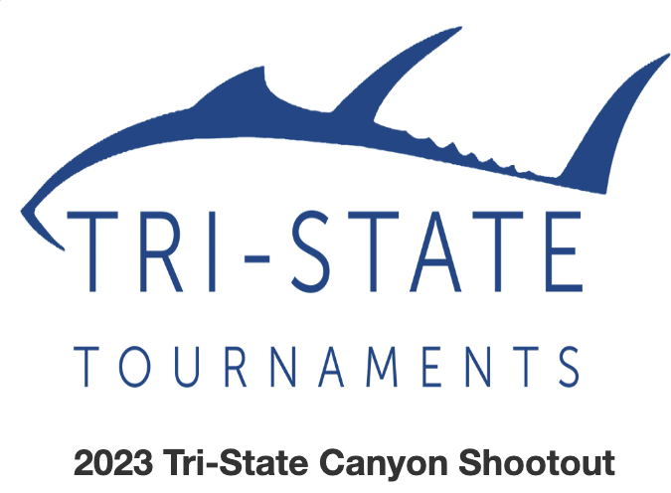

Veteran Angler Charters Tri-State Canyon Shootout Event Application/Nomination Form

Applicant / Nominee Information
Name (Last, First, Middle Initial):
Mailing Address:
Phone Number:
E-mail Address:
Branch/Service:
Active Duty, Reserve, or National Guard:
Date of Entry and Separation or Retirement:
Highest Rank Achieved:
Military Honors and Awards:
Nominator Information (if applicable)
Name (Last, First, Middle Initial):
Mailing Address:
Phone Number:
E-mail Address:
Relation to Nominee:

Page 1 of 2
In the space below, please describe why you believe you (or the person you are nominating) should be considered for selection to participate in this trip. Please include any relevant information pertaining to your (or the person you are nominating’s) military service.
By signing below, you are confirming that you, or the person being nominated, meet(s) the eligibility requirements provided in the event solicitation and commits to participate for the entire duration of the event.
Name:
Date:

The completed form must be emailed to tristate@veterananglercharters.org no later than 2359 EST on 1 April 2023. Any questions relating to the application/nomination process, eligibility requirements, or the event should be sent to tristate@veterananglercharters.org. Thank you for your service!

Page 2 of 2

If you are unsure if you meet the physical requirements, please contact Veteran Angler Charters for additional clarification.

